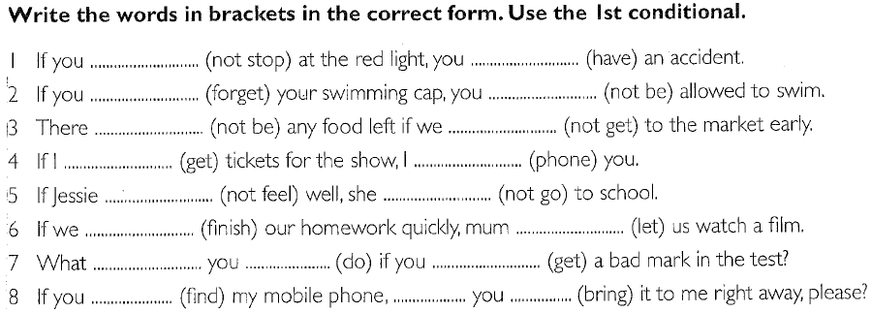

KEY:
if - clauses TYPE I
- If you do not stop at the red light, you will have an accident.
- If you forget your swimming cap, you will not be allowed to swim.
- There will not be any food left if we do not get to the market early.
- If I get tickets for the show, I will phone you.
- If Jessie does not feel well, she will not go to school.
- If we finish our homework quickly, mum will let us watch a film.
- What will you do if you get a bad mark in the test?
- If you find my mobile phone, will you bring it to me right away, please?

if - clauses TYPE I (with shortened forms)

- If you don't stop at the red light, you'll have an accident.
- If you forget your swimming cap, you won't be allowed to swim.
- There won't be any food left if we don't get to the market early.
- If I get tickets for the show, I'll phone you.
- If Jessie doesn't feel well, she won't go to school.
- If we finish our homework quickly, mum will let us watch a film.
- What will you do if you get a bad mark in the test?
- If you find my mobile phone, will you bring it to me right away, please?

if - clauses TYPE II
- If you did not stop at the red light, you would have an accident.
- If you forgot your swimming cap, you would not be allowed to swim.
- There would not be any food left if we did not get to the market early.
- If I got tickets for the show, I would phone you.
- If Jessie didn't feel well, she would not go to school.
- If we finished our homework quickly, mum would let us watch a film.
- What would you do if you got a bad mark in the test?
- If you found my mobile phone, would you bring it to me right away, please?

