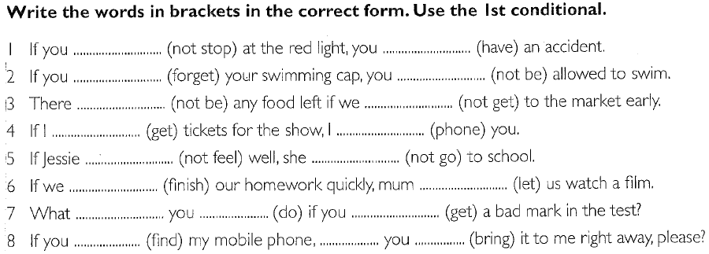

KEY:

if - clauses TYPE I

1. If you **do not stop** at the red light, you **will have** an accident.
2. If you **forget** your swimming cap, you **will not be** allowed to swim.
3. There **will not be** any food left if we **do not get** to the market early.
4. If I **get** tickets for the show, I **will phone** you.
5. If Jessie **does not feel** well, she **will not go** to school.
6. If we **finish** our homework quickly, mum **will** **let** us watch a film.
7. What **will** you **do** if you **get** a bad mark in the test?
8. If you **find** my mobile phone, **will** you **bring** it to me right away, please?

if - clauses TYPE I (with shortened forms)

1. If you **don't stop** at the red light, you**'ll have** an accident.
2. If you **forget** your swimming cap, you **won't be** allowed to swim.
3. There **won't be** any food left if we **don't get** to the market early.
4. If I **get** tickets for the show, I**'ll phone** you.
5. If Jessie **doesn't feel** well, she **won't go** to school.
6. If we **finish** our homework quickly, mum **will let** us watch a film.
7. What **will you do** if you **get** a bad mark in the test?
8. If you **find** my mobile phone, **will you bring** it to me right away, please?

if - clauses TYPE II

1. If you **did not stop** at the red light, you **would have** an accident.
2. If you **forgot** your swimming cap, you **would not be** allowed to swim.
3. There **would not be** any food left if we **did not get** to the market early.
4. If I **got** tickets for the show, I **would phone** you.
5. If Jessie **didn't feel** well, she **would not go** to school.
6. If we **finished** our homework quickly, mum **would let** us watch a film.
7. What **would** you **do** if you **got** a bad mark in the test?
8. If you **found** my mobile phone, **would** you **bring** it to me right away, please?